08.03.2018

Readings Walton → chs. 3,4,6,7 + Toulmin introduction, ch.3 “the layout of arguments” pp.94-127

Informal logic → *branch of logic whose task is to develop non formal (not restricted to logical form) procedures and criteria etc. to construct, asses and evaluate arguments in practice*.

But if by logic we only mean the study of axiomatized systems, clearly the term logic here is misapplied.

Instead, if we believe that there is a logic in the way in which we use our natural language and also in what we do and in the use we make of language, it became necessary to figure out how we argue within this context and by what tool we are able to describe the way we engage in logical argumentation.

When we look at this practical logic, the tool of logic, in the strict sense, they’re not enough or neither adequate.

We are overriding the narrow sense of logic, entering a very wide field.

There are two aspects that qualify the informal logic that are irrelevant in the field of formal logic:

1. Arguments are here to be discovered: there are no pre-established forms in which we can recognize syllogisms, etc. → we need to make them appear to us, not automatic procedure
2. We move from artificial language to natural language → it makes two important moves: from artificial from natural language (from a precise syntax and semantics to context where language is used in a more contested way, fluent way) and one from arguments as property of statements to arguments as part of social activities (= *logical type of reasoning which includes two parties interacting with each other, one answering to the other*).

Its domain is highly **pragmatic**: its aim is to evaluate how reasoning is/was used in a given case for some communicative purpose, in a given text of discourse.

→ it is important contextualization in this type of logic

It does not have a very long history: it has struggled to be accepted as a domain of logic. Its domain overlaps with other disciplines, other fields of inquiry: dialectics, practical reasoning, critical thinking, applied epistemology, etc. so it is unclear the domain and the aim of informal logic, why it has that make it different from other disciplines.

We have here different/specific tools and different purposes: we are for instance assessing quality rather than validity.

Walton/Godden : “In order to be good, arguments do not require true premises linked to their conclusions by valid inferences; rather good arguments require premises that are *acceptable*, premises that are *relevant* to the conclusion, and premises that provide *sufficient support* or evidence for the acceptability of the conclusion”

We need firstly to identify the context: identify where do people exchange information, their purposes, background information…

A first context is the **debate**: regulated by a series of rules that determine the way in which the parties/speakers express their ideas; it is a step above a quarrel (it is more congenial to some king of logical reasoning). The aim is also to win the argument: what qualifies as a successful argument is not necessary the best logical argument. The argument that wins the argument not always is the best logically speaking.

Debates are not only ‘me against you’ but always people want to negotiate position: it can be a dialogue that makes room for negotiation. Here the goal is not to see my argument prevail but trying to find the most balanced possible outcome between the different views.

Another context is **critical discussion**: here we have at least two arguers with a thesis to support and each of them want to persuade the other that he/she is right. Similar to the debate but with a specific purpose. In this types of discussion the prevailing strategy is that of some kind of logical reasoning: we adopt a critical stamp so to make the best case for our thesis. The different participants intend to prove that the thesis supported from certain premises actually is a thesis that the other one can see, you might not be willing to accept the consequences but you have to recognize the premises from which you move the argument.

Another context is the one of an **inquiry**: it is somehow different from the first two because here you start from something that you do not know and you want to figure out the answer (very frequent in politics, in the legal field, in science …). The aim is to establish reliable knowledge to a subject matter with the satisfaction of all parts included in them: the focus of inquiries is often **facts**. They can be shared by anyone, so it is a fitting element.

How do we construct arguments? What is the layout? **Toulmin’s model**. Good context should be assessed in terms of these six parts:

* ***Data***: The facts or evidence → we use them in order to prove our argument
* ***Claim***: The statement being argued (a thesis) → what is at stake, what is the statement we are claiming about
* ***Warrants***: bridges between the claim and the data → it is like an hypothetical kind of reasoning that creates a connection between the claim and the data, so to make one relevant to the other
* 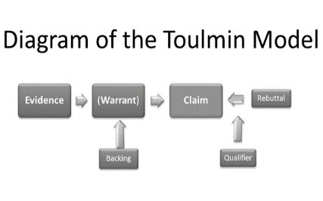***Qualifiers***: conditions under which the argument is true → statements that qualify or limit the strength of my claim by offering a series of conditions that create a borderline for the claim that we support
* ***Rebuttals***: Counter-arguments → what makes an argument good is discarding these counter-arguments
* ***Backing***: Statements that serve to support the warrants → what we use to support our hypothesis that there is a warrant between a data and our claim

It is important to notice that if we are talking about argument in formal terms, nothing can be taken as something final, conclusive: we always have to keep an open eye on where the argument is actually taking us.

EXAMPLE from John Gage, *The Shape of Reason:*

*Congress should ban animal research* (*=*thesis) *because animals are tortured in experiments that have no necessary benefit for humans such as the testing of cosmetics* (= data)*. The well-being of animals is more important than the profits of the cosmetics industry* (= warrant)*. Only congress has the authority to make such a law* (= warrant) *because the corporations can simply move from state to state to avoid legal penalties* (=backing)*. Of course, this ban should not apply to medical research* (= qualifier)*. A law to ban all research would go too far* (= rebuttals)*. So, the law would probably have to be carefully written to define the kinds of research intended.”*

Toulmin emphasises a difference between **analytic** and **substantial** **arguments**:

analytic arguments: but they are very rare according to Toulmin, because they are almost tautologies

* Anne is one of Jack’s sisters
* All Jack’s sisters have red hair



* So, Anne has red hair

*We make claims about the future, and back them by reference to our experience of how things have gone in the past; we make assertions about a man’s feelings, or about his legal status, and back them by reference to his utterances and gestures, or to his place of birth and to the statuses about his nationality; we adopt moral positions, and pass aesthetic judgements, and declare support for scientific theories or political causes, in each case producing as grounds for our conclusion statements of quite other logical types than the conclusion itself. Whenever we do any of those things, there can be no question of the conclusion’s being regarded as a mere restatement in other words of something already stated implicitly [in the premise] (….) the step we take in passing to the conclusion from the information we have to rely on (…) is a substantial one*

To distinguish you should look at the realm of complexities hidden. Let’s try to transform analytic arguments in substantial ones: “All Jack’s sister have red hair” ­

* Datum: Anne is one of Jack’s sisters
* Backing: All Jack’s sisters have previously been observed to have red hair
* Conclusion: So, presumably, Anne now has red hair

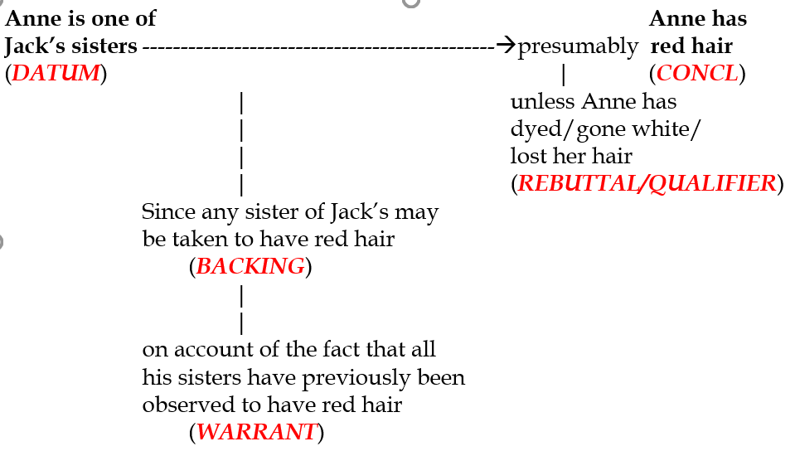

The argument loses its… we cannot establish the conclusion with absolute certainty, which is the very point of an analytic kind of argument. We actually do not lose any track that we are actually reasoning if we add qualifiers etc 🡪 we are not reasoning illogically, but rationally. We are just reasoning differently.

Any analytic argument can be turned into a substantial one.

There are a lot of informal arguments that we can discuss about.

* appeal to **emotions** → when we argue in everyday life we know that logical reasoning is interrelate with emotions. Appeals to emotions are not inherently illogical. The mere presence of emotions is not totally but not always good emotions are appealed to; it deserves to be described and analysed to see where they take our argument. Often the conclusions are more compelling than strong arguments: they tend to be weak arguments. Despite the fact that they seem attractive, they tend to be weak in terms of plausibility. They quite easily end to be fallacies.
  + **Argument *ad populum***: The fallacy of attempting to win popular assent to a conclusion by arousing the feeling and enthusiasms of the multitude (popular sentiment) rather than appealing to good evidence 🡪 here what is bad is not the appeal to emotions as such, but the fact that they are used as substitutive of evidences/information; they are persuasive, they sound good. There are several variation of this argument, but they are all fallacies:
    - ***Snob appeal****:*get to a conclusion on the basis on elite beliefs.

Person **L** says statement **p** or argument **A**.  
Person **L** is in the elite.  
Statement **p** is true or argument **A** is good.

* + - ***Bandwagon****:* many people believe a thing, therefore it is true

Most, many, or all persons believe statement **p** is true.  
Statement p is true.

* + - ***Emotion proper****:* you use a language that convey a series of feelings that we share with an audience and on the basis of how we dress our argument we get consensus.

enthusiasm, pride, anger, or disgust are used to express evidence for statement **p**  
Statement **p** is true.

* ***Ad baculum*****arguments**: (“baculum” is a stick in Latin) the fallacy of resorting to force or threat of using force to make someone accept the conclusion of an argument.

in the example: what Americans want = the right thing to do (ad populum) + if they disagree, there will be consequences (ad baculum)

a threat can be used as a tool to convince someone to do something; often though there is no real connection between the content of a threat and the substance of the conclusion that we are seeking. Here the fallacy has to do with relevance 🡪 *ignoration elenchi* argument: fallacy of irrelevant conclusion, missing the point

* ***Ad hominem* arguments**“argument directed to the man” where the focus is on attacking the arguer. How? Calling into question his/her character, trustworthiness, honesty, integrity, motivations. There is a personal attack, heavily charged with emotions. They easily became offensive arguments. BUT not all *ad hominem* argument are fallacies: sometimes questioning the arguers credentials is a reasonable move (e.g. wandering about the competence of a professional, about the motivations that lead a person to say some things…) → particularly used when there is a gap of evidence
* appeal to **authority →** Arguments that target someone in order to enhance the credibility of the person, which in its turn enhance the credibility of a certain claim or conclusion (supported by this person)

it goes to the opposite direction of the ‘ad hominem’ argument, because in this latter we target someone with the intent of destroy his/her credibility whereas the former targets someone but in order to enhance the credibility of the person, therefore then enhancing the credibility of the claim.

* Arguments ***ad verecundiam***: John Locke was the first to use this expression to describe types of argument used also in ordinary conversation and the first to warn us to the use of this type of arguments, which can fall easily into fallacies. We see a discussion by Locke where he talks about a number of arguments that man ordinarily use in order to prevail on someone or to win his assent. “*The first is to allege the opinion of men whose parts, learning, eminency, power, or some other cause has gained a name, and settled their reputation in the common esteem with some kind of authority. When men are established in any kind of dignity, it is thought a breach of modesty for others to derogate any way from it, and question the authority of men who are in possession of it. This is apt to be censured, as carrying with it too much pride, when a man does not readily yield to the determination of approved authors, which is wont to be received with respect and submission by others and it is looked upon with insolence, for a man to set up and adhere to his opinion against the current stream of antiquity; or to put it in the balance against that of some learned doctor, or otherwise approved writer. Whoever backs his tenets with such authorities, thinks he ought thereby to carry the cause, and is ready to style it impudence in any one who shall stand out against them. This I think may be called argumentum ad verecundiam”*

Its format “A is (is considered to be) an authority in the field F” → A claims x regarding F → x is true

* First problem: it is an inductive argument somehow, how can we demonstrate A’s authority in the claimed field? Claiming someone’s authority is not given but needs to be demonstrated, here it is treated like a premises without demonstration
* Second problem: logical fallacy. The truth of the conclusion does not depend on who asserts it! There is not a ‘medium’ that indicates that an authority is always right. Authority then is not a sufficient condition to infer something. And still this does not necessarily mean that the conclusion is false, but invalid.

How do we guarantee when A has enough authority to claim that x is true, and which conditions are to be established when considering an authoritarian claim?

We do not have evidence logically speaking that A is an authority: how can we assess the expertise of someone? And this is a problem also considering the relevant field: not all experts are the same, so how do we distinguish one expert from another?

In scientific context, A is competent in a particular field and this field is well established (and acknowledged to be established). So, what gives authority to a particular discipline/field? → e.g. the authority of science is given by how the science investigates facts and by the context where science investigates facts.

Thomas Kuhn explained the context in which scientific researches are developed, the one he called the *“****scientific paradigms****”*. The scientist who researches into the paradigm, is also committed to the paradigm itself, they believe in it, becoming *“****normal scientist****”*. It seems the more established the paradigm is the more mature the field will be and the less controversial the results of this paradigm will be.

It seems like a consensus group. By appealing to the paradigm we attribute authority to its member.

→ in order to be a normal scientist he/she needs to believe in the paradigm, being uncritical, without questioning the very basis on which the paradigm relies to. So they become figures of authority with two characteristics: (1) sufficient knowledge in the field under investigation, (2) supported in their claims by a widely acknowledge paradigm and (3) no confounders.

≠ Popper!! He did not believe in authority of normal scientist, he believed they believed uncritically to previous dogmas. It is a bad example to follow. We should beware of blind acceptance. Then, who is to be trusted?

1. It depends on the context of work of the individual → ex. in a court you should not be risky or speculative on hypothesis, while in a scientific lab you should/could.

How can we judge? Through delegating to experts our decisions, to also secondary sources. Trust in society is important and this is not proportional to the quantity of information we get, but rather comes from being able to check the information that we receive, to be able to check also the sources of this information ⇨ from critical claims

* appeal to **relevance** : in every argument there is always an issue at stake, a proposition or more propositions under discussion. To reach a conclusion we need to make sure that the argument actually lead or/and proves the conclusion. So there must be a *logical entailment* of the conclusions in the premises. But is it a good way to think? It is logical entailment enough? By itself, no, it is not, because this link needs another element to take into account: RELEVANCE.

There seem to be no logical connection between them, but neither a logical contradiction: they are consistent but this is not enough to make a sound judgement.

A. John was on the crime scene at the moment of a robbery

B. John has a pistol of the type used in the robbery

C. John deposited a large amount of money the day after the robbery

D. John is the robber

We need to create coherence between them in order to conclude D. The logician Lewis talked about **congruence**: assuming A and B increases the probability that C; and given B and C, the probability of D increases.

The congruence of A,B and C depends on the empirical data that we have to believe in A, B and C but not enough for their relevance. So it seems that relevance is also primary to statements.

Disputing on relevance is usual in the context of courts and trials.

There are different levels of relevance (Walton book, Informal Logic, ch.3):

* Global relevance ⇨ when we look at the entirety of the argument, the whole argument to the conclusion
* Local relevance ⇨ quick exchange on questions and answers (“is john guilty? Look at its red hair); they’re lik building blocks to the final picture
* Subject-matter relevance ⇨ bringing in extra-features in order to diverge attention to the subject at stake
* Probative relevance or *pertinence* ⇨ “John is red haired and John committed a crime” both are subject-matter related but not relevant to each other: the one cannot prove the other one

These levels normally come together.

Therefore you cannot in practice judge an argument only on the basis of its parts, but in its totality. This is why context’s important.

Informal logic gives us tools on reasoning not necessarily included in formal logic, but equally important.

In conclusion, how should we think about logic?

1. Not only formal logic
2. Logic is an important tool also for non-pure logicians
3. It is important in the moment we try to test logic in contexts other than logic itself: different context select and channel our reasoning, selecting means and methods we need in order to reason (well) and assess the way we reason.
4. It opens up a critical channel
5. Always be sound, coherent, transparent, open to evidence… not give up on being logic !!

EXAM 23rd March 2018:

* Basic terminology, notations, philosophy of science
* Knowledge of main inferences, challenges, critics, problems
* Ability to see logic in context of use (e.g. science)

More specific:

1. Readings are important !!!!!!
2. See how you reason → 3 open/structured questions: not on knowledge, but if you are able to answer question on the background of what you know. They will be specific, not having everything on the paper like a textbook: you will need to plan your answers.

e.g. Has Hume answered the problem of induction in a way that it faces the challenge of irrationality? (=mock questions on moodle)

1. 2 hours : you need a plan for each answer, it is important